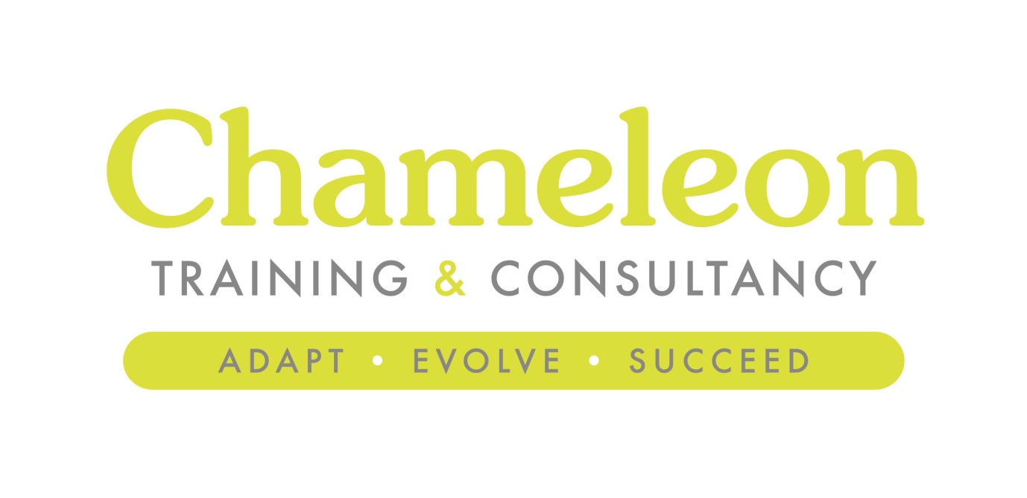
Courtesy of

XXX School
Marketing Strategy

2017

Version 1

Executive Summary

Up front and personal, the Executive Summary sits at the start of your document and really does set out very clearly the purpose of your school marketing plan, presenting the main objectives and recommendations. It also serves to remind those responsible for its implementation of the original aims and objectives, preventing 'mission creep' and providing a useful way to reflect and record success (or otherwise).

For example: XX aims to be outward-looking, client-focused and responsive to change, providing the very best educational experience for our young people. XX can be the best state school in the region. This strategy has been formulated to help create the conditions for wisdom to flourish allowing staff and students to achieve. The strategy will specifically work towards these core objectives:

Situational Analysis

The situational analysis or 'environmental scanning' part of the plan is designed to help identify your strengths and challenges. The idea is to analyse, understand and define current and future environments that the organisation will be operating within.

There are a number of analytic tools to help articulate this but essentially you’re trying to gain intelligence on the external environment and your capability to thrive within that environment.

SWOT Analysis

Complete an analysis of Strengths, Weaknesses, Opportunities and Threats reflecting the current position of the school, providing a critical review of the internal factors which affect your position, and the external factors which offer opportunities and threats to your development.

A simple SWOT analysis can provide a critical and honest review of the current status of the school, considering both internal and external factors which offer opportunity and threat to future developments. Of course you will be looking to convert those weaknesses to strengths and threats to opportunities. Often a simple SWOT analysis can help identify issues which can be worked on at a later date if they’re not critical to the immediate success of your core objectives.

Strengths | Weaknesses
Opportunities | Threats
Gap Analysis

A Gap Analysis can be used to determine what steps need to be taken in order to move from the current state to a future, more desirable state, within a given timeframe. A useful tool to help visualise actions over a given timeframe.

Our current position:

Our desired position:

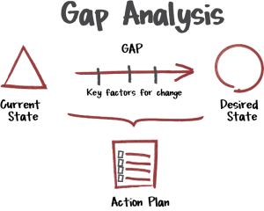

PESTLE Analysis

Its foundations may lie in the business world but a PESTLE analysis is useful for framing the wider context your school may operate within, and this is especially pertinent today with political and financial pressures like never before.

A PESTLE analysis is an exploration of factors potentially impacting on the school, categorised in the table below. There will be many factors pertaining to all schools, such as the new funding formula, but others that will be seen to have less immediate relevance, such as Brexit for example. Either way, if you can give consideration to these factors you’re more likely to successfully navigate around them.

Trends and factors | Significance in school | Action required
Political
Economic
Socio-cultural
Technological
Legal
Environmental

Implications

To reach the vision of becoming a world-class education provider you need to have a full understanding of the world beyond the campus – the threats and opportunities presented by the wider environment and the needs of your students and parents (current and future). Adopting a proactive and strategic approach enables school leaders to be ahead of the game, adapting as necessary to ensure the very best provision for your young people.

These are the main implications of the situational analysis:

Internal Assessment

Here we identify and understand cultures and values. We build upon, nurture and extend those values – 'shaped beliefs act as catalyst for consistent actions by members.' Hollensen (2001)

Review your organisation looking at structure, purpose, lines of authority and responsibilities. Identify the new skills required for your staff to become outstanding practitioners.

Kawasaki (95) talks of creating a 'strategic cause':

Cause embodies a vision – articulate a clear sense of purpose, establishing hopes and aspirations.
Cause seizes high ground – embodies a clear set of shared values aimed at significantly improving student experiences.
Cause redefines experiences – seeks new ways of doing things, creating an attractive future.
Cause catalyses strong feelings – makes people want to belong and buy into the vision. Parents, students and staff are proud to be part of the school.

Small things combine to provide a powerful message about your school:

- Visual identify and brand image
- Consistent message and look
- Our culture and values
- Aspirations
Value Mapping

Identify and understand culture and values. You’ll almost certainly have multiple objectives for your marketing plan, and the plan should also sit alongside any fundraising strategy you have in place. As such the purpose of the marketing strategy may be, in part at least, to attract business partners and commercial sponsors, so it is critical they understand and share your culture and ethos.

You’ll need to sharpen the vision for your school so it is crystal clear and simple to disseminate to others.

Defining core values can be a cathartic and transformational process and it needn’t be a complicated and drawn-out affair. You may find a mission statement is sufficient but a more visual and effective value-mapping exercise can bring in the input of the key stakeholders who are involved in your offering.

Keep it simple – ask small focus groups (students and staff) to jot down their gut feelings about your school based around four themes; relationships, functional, beliefs and emotional.

Here you’re keying in some aspects of your school which make it unique; your relationships with key groups, the facilities available (functional), skills and knowledge (functional) and the key cultural drivers of your school (belief).

RELATIONSHIP | FUNCTIONAL
BELIEF | EMOTIONAL

You can use your new core values to define these messages, to distil them into no more than three key features of your offer:

Key Message 1

_______________________________________________________________

Key Message 2

_______________________________________________________________

Key Message 3
_______________________________________________________________

Strategic Planning

Operational Planning (shorter term view = Year 1)

Business Planning (medium term view = Year 2-3)

Strategic Planning (longer term view = Year 4-5)

Programme

Focus: Operational & Business Planning 2017- 2019

Main theme | Individual action points | Delivery date

Agreed Priority Focus 2017-2018

Main Theme | Individual action points | Timescales

Budget

Category | Budgeted amount (£) | Actual cost (£) | Difference (+/-£)

Resources
Support – Marketing shouldn’t be done in isolation, it’s a team sport! As such one of the key aspects of any marketing plan is resources – identifying those with the skills, appetite and desire to get involved.

Name | Current role | Support offered

Monitoring and evaluation

Reflection – this document will evolve over time. It is important to reflect on processes and activities which worked and those which didn’t meet your expectations. The difference between what an organisation believes is possible in the approval of the strategy, and what actually happens a few months in to its implementation are important to track. Feed this into future revisions of the strategy and its implementation. It is also important that the whole organisation learns from this process so that your marketing activities are effective now and in the future.

Successes – what worked and why:

Challenges – what didn’t work and why:

